**KISAASI COLLEGE SCHOOL**

**END OF TERM III ASSESSMENT 2023**

**S1 PHYSICS (COMPETENCE BASED CURRICULUM)**

**TIME: 2 HOURS**

**Name......................................................................................................................**

**Attempt all questions**

**1 (a) Define density and give its S1 unit. (02 scores)**

**………………………………………………………………………………………………………………………………………………………………………………………………………………………………...........................................................................................................................**

**(b) If the stone of 20g was immersed in water and it raised its volume by 40cm3, find the density of the stone hence its relative density. (03 marks)**

**………………………………………………………………………………………………………………………………………………………………………………………………………………………………...................................................................................………………………………………………………………………………………………………………………………………………………………………………………………………………………………..............................................................................................................................................................**

**2 (a) Distinguish between fundamental quantity and derived quantities and give 3 examples of each. (05 marks)**

**………………………………………………………………………………………………………………………………………………………………………………………………………………………………...................................................................................……………………………………………………………………………………………………………………………………………………………………………………………………………………………….....................................................................**

**(b) A needle was placed on the blotting paper placed on the water surface.**

**(i) State what was observed (01 mark)**

**………………………………………………………………………………………………………………………………………………………………………………………………………………**

**(ii) Explain your observation. (01 mark)**

**………………………………………………………………………………………………………………………………………………………………………………………………………………**

**(iii) What will happen after some time? Explain your reasoning. (02 marks)**

**………………………………………………………………………………………………………………………………………………………………………………………………………………………………………………………………………………………………………………………**

**(iv) Why do you think insects are able to walk on water? (01mark)**

**………………………………………………………………………………………………………………………………………………………………………………………………………………………………………………………………………………………………………………………………………………………………………………………………………………………………**

**3 a). A small amount of water placed on wax forms small droplets but spreads out when placed on glass. Explain the observation. (03 marks)**

**………………………………………………………………………………………………………………………………………………………………………………………………………………………………...........................................................................................................................**

**(c) State what is observed when smoke particles are observed under a microscope. (01 mark)**

**………………………………………………………………………………………………………………………………………………………………………………………………………………………………………………………………………………………………………………………**

**4. (a) Define the term force and give its S1 unit. (02 marks)**

**………………………………………………………………………………………………………………………………………………………………………………………………………………………………...........................................................................................................................**

**(b) what happens to a rubber band when much force is applied to it. Explain your reasoning. (02 marks)**

**………………………………………………………………………………………………………………………………………………………………………………………………………………………………..........................................................................................................................**

**(c) Give 2 types of forces and their applications. (04 marks)**

**………………………………………………………………………………………………………………………………………………………………………………………………………………………………...................................................................................………………………………………………………………………………………………………………………………………………………………………………………………………………………………...............................................................................................................................................................**

**(d) Two forces of 5N and 12N acts at right angles on a block of mass 6.5Kg, Find the resultant force of the block and hence its acceleration. (03 marks)**

**………………………………………………………………………………………………………………………………………………………………………………………………………………………………...................................................................................………………………………………………………………………………………………………………………………………………………………………………………………………………………………................................................................................................................................................................**

**5. Mikka got a glittering stone and he was very happy that he was going to become rich. He told his family members that it was gold. The family members disagreed with him. As a S1 physics learner, Make a write up to solve the disagreements in the family (Density of pure gold is 1.92g/cm3 (10 scores)**

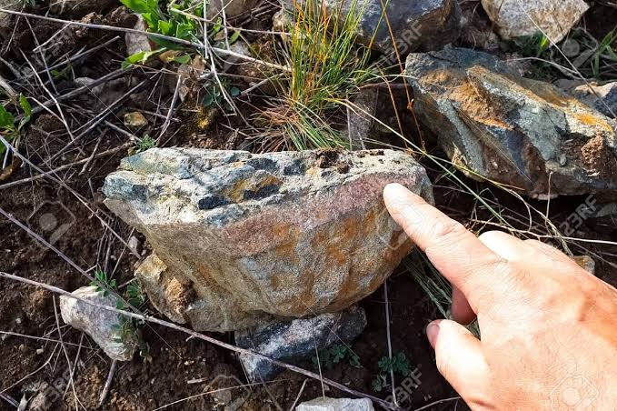

**………………………………………………………………………………………………………………………………………………………………………………………………………………………………...................................................................................………………………………………………………………………………………………………………………………………………………………………………………………………………………………...................................................................................………………………………………………………………………………………………………………………………………………………………………………………………………………………………...................................................................................………………………………………………………………………………………………………………………………………………………………………………………………………………………………...................................................................................………………………………………………………………………………………………………………………………………………………………………………………………………………………………...................................................................................………………………………………………………………………………………………………………………………………………………………………………………………………………………………...............................................……………………………………………………………………………………………...................................................................................………………………………………………………………………………………………………………………………………………………………………………………………………………………………...................................................................................………………………………………………………………………………………………………………………………………………………………………………………………………………………………...............................................……………………………………………………………………………………………...................................................................................………………………………………………………………………………………………………………………………………………………………………………………………………………………………...................................................................................………………………………………………………………………………………………………………………………………………………………………………………………………………………………...............................................**

**6. In Kisaasi village, there is a certain old man living in darkness in his hut. You felt pity for him. One evening you decided to visit him and found that all he had in his hut were an empty tin, paraffin, a cotton cloth, a razor blade and a matchbox. Develop guidelines the old man should follow to use the available materials at his home to solve this problem. (10 Scores)**

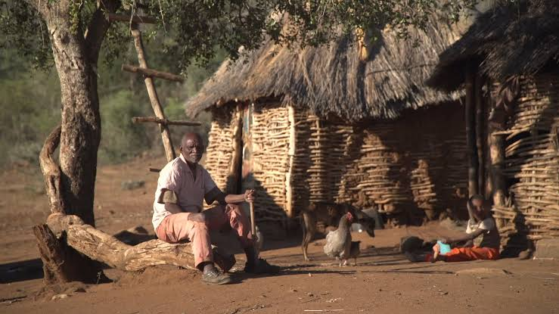

**………………………………………………………………………………………………………………………………………………………………………………………………………………………………...................................................................................………………………………………………………………………………………………………………………………………………………………………………………………………………………………...................................................................................………………………………………………………………………………………………………………………………………………………………………………………………………………………………...................................................................................………………………………………………………………………………………………………………………………………………………………………………………………………………………………...................................................................................………………………………………………………………………………………………………………………………………………………………………………………………………………………………...................................................................................………………………………………………………………………………………………………………………………………………………………………………………………………………………………...................................................................................………………………………………………………………………………………………………………………………………………………………………………………………………………………………...................................................................................………………………………………………………………………………………………………………………………………………………………………………………………………………………………...................................................................................………………………………………………………………………………………………………………………………………………………………………………………………………………………………...................................................................................………………………………………………………………………………………………………………………………………………………………………………………………………………………………...................................................................................………………………………………………………………………………………………………………………………………………………………………………………………………………………………...................................................................................……………………………………………………………………………………………………………………………………………………………………………………………………………………………….................**

**\*\*\*success\*\*\***